TEXT TABLE USING CALCULATION FIELD

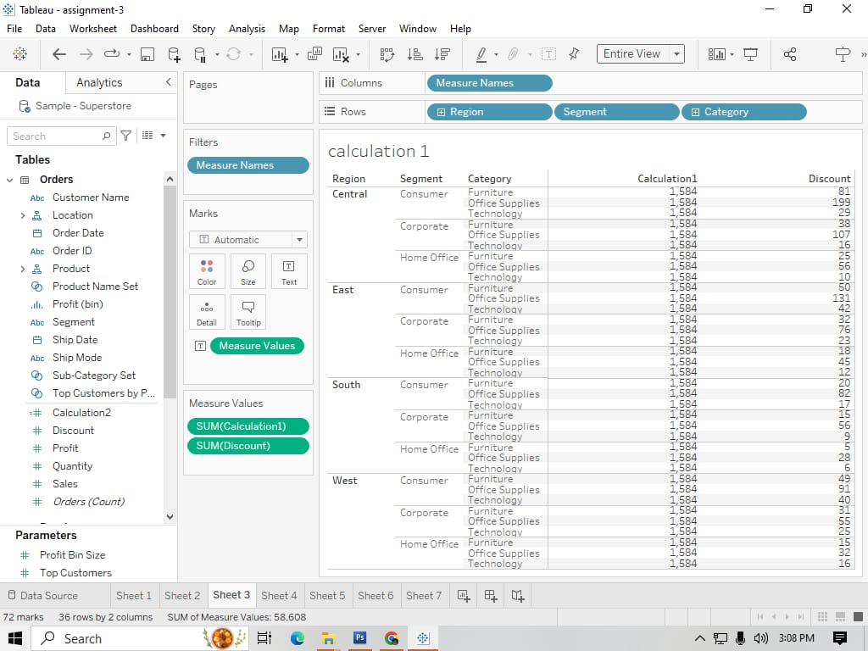

To find out the discount various category products of segments in various regions I have created a calculation and created a text table visualisation.

TEXT TABLE USING CALCULATION FIELD

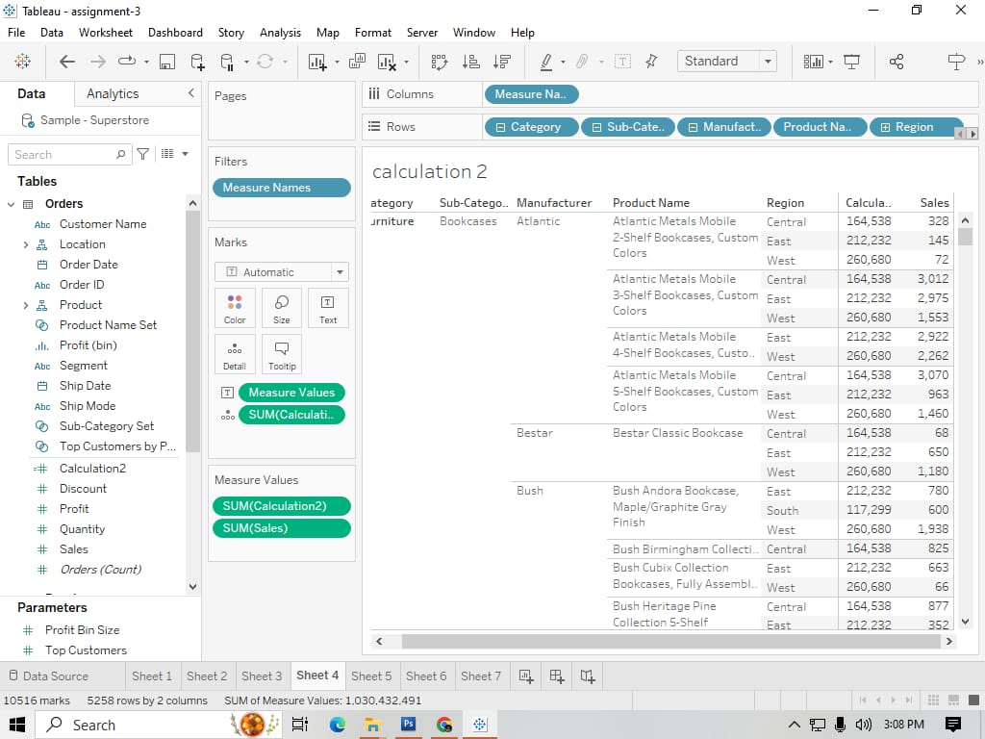

To find out the sales of various products over various regions we have used calculation field and created a texttable.

BAR CHART USING SUB CATEGORY SET

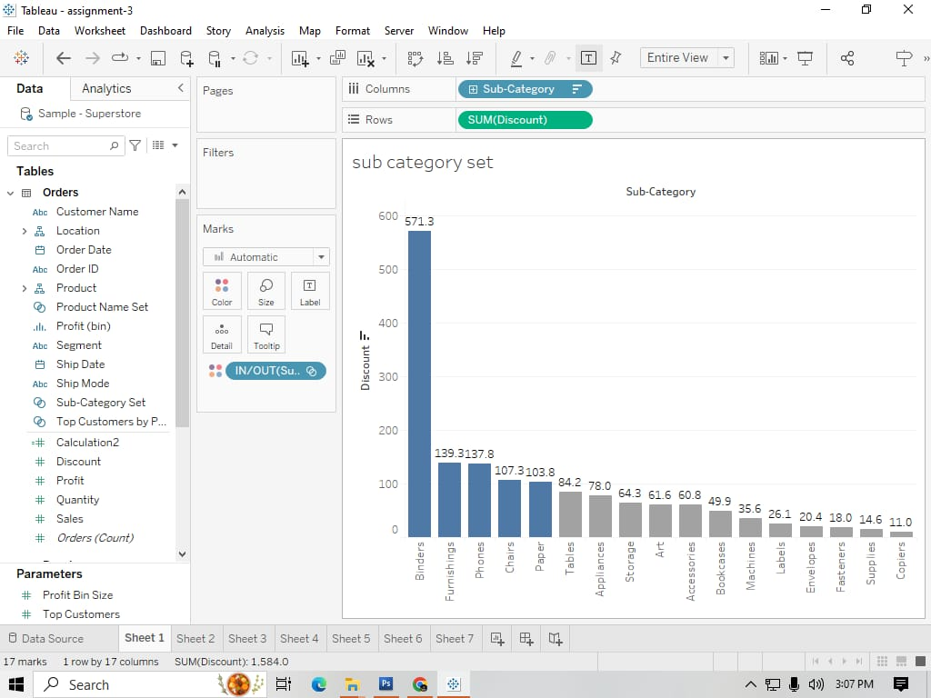

Created bar chart visualisation to find the discounts of various products in sub category. Here I have created a set for the top 5 products those are having highest discounts.

QUICK TABLE CALCULATION 1

YEAR OVER YEAR GROWTH

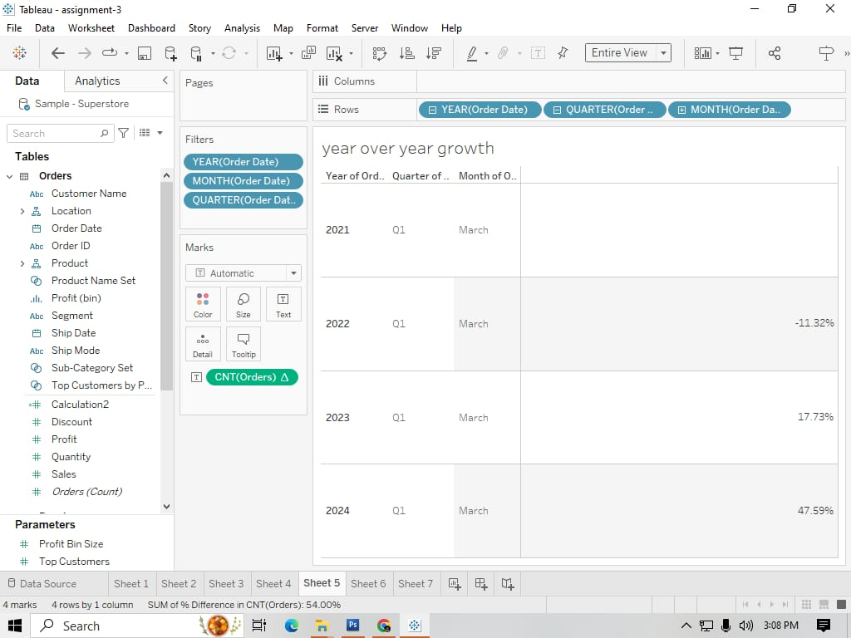

Used Quick table calculation Year over year growth to find the orders of march month over 2021,2022,2023 and 2024.

QUICK TABLE CALCULATION 2

PERCENTILE

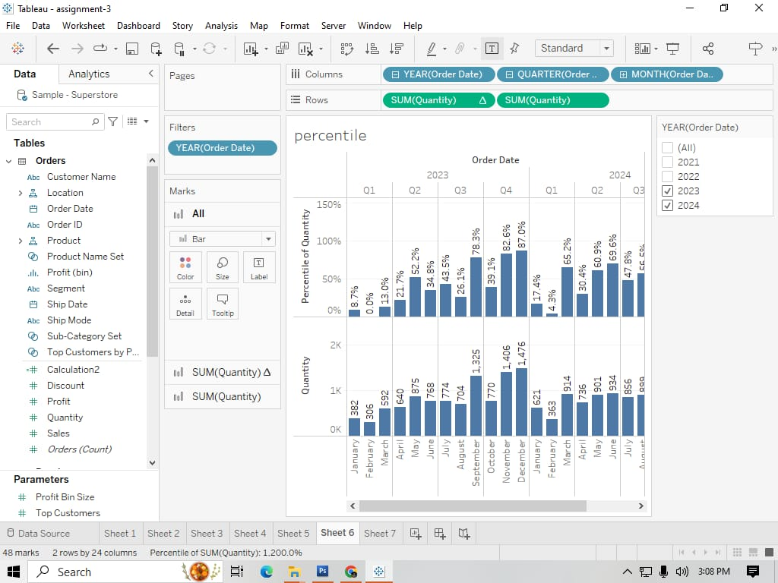

Used percentile in quick table calculation to find the quantity and percentile of quantity of various quarters over 2023 and 2024.

QUICK TABLE CALCULATION 3

RANK

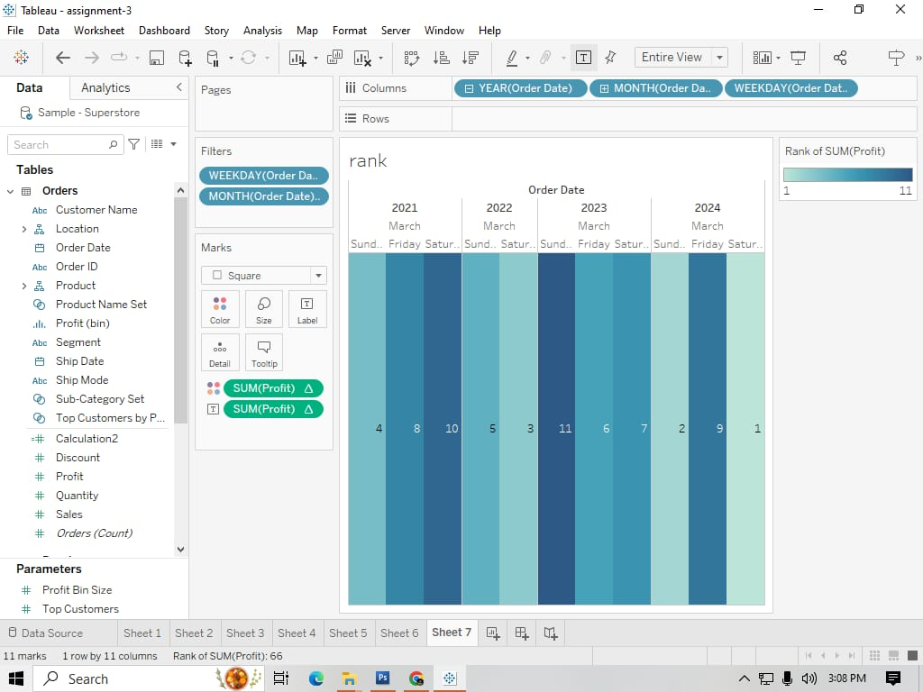

Used rank in quick table calculation for order date over four years 2021,2022,2023,2024 to find the profit and made the highlight table.